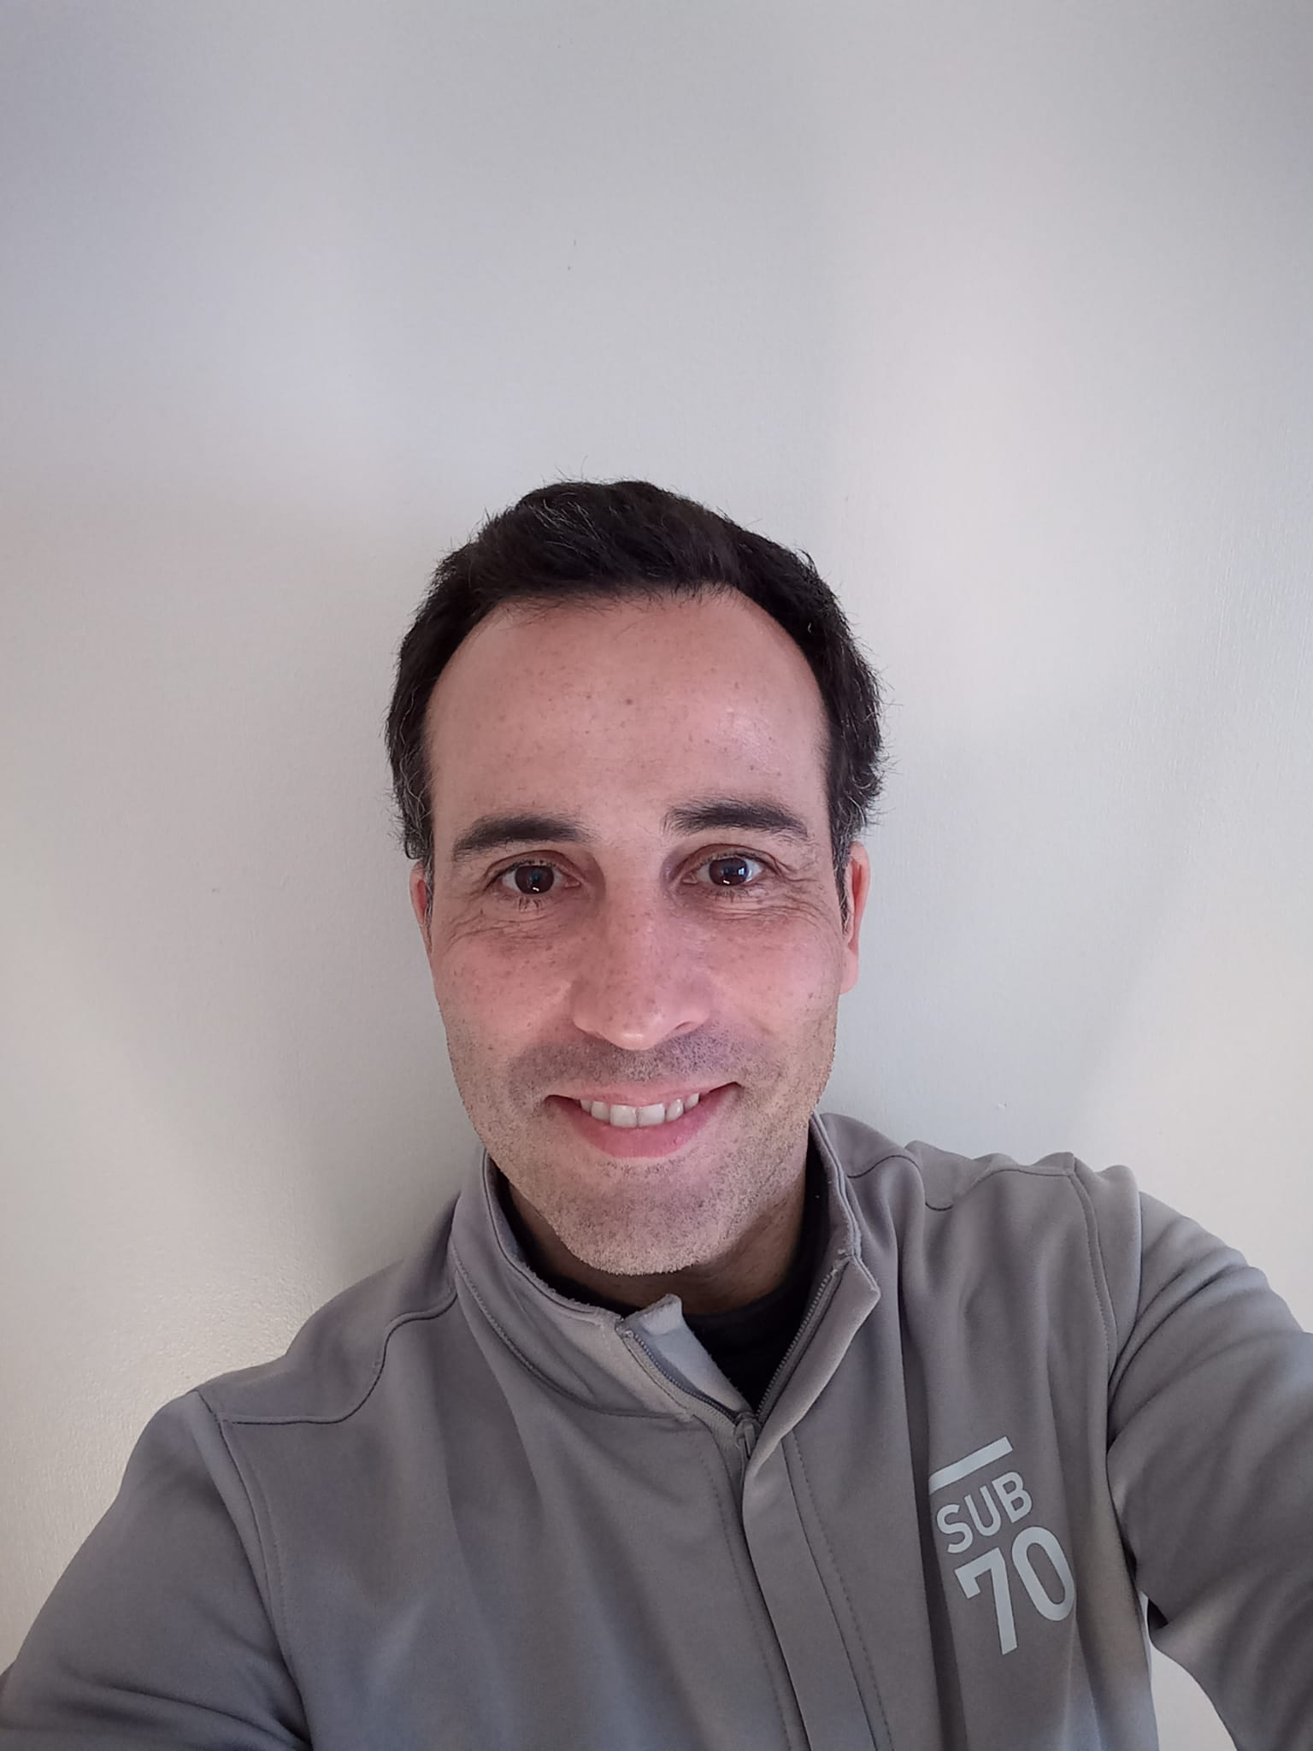

I was born in the Huelva, at the South West of Spain where golf was firstly ever play in the country by 1890. In spite of that, I grabbed golf by mere coincidence, by 2005 my wife (at that time fiancée) was studying at NYU and lived at the 54th St, a stone throw of the Lexington Ave Golfsmith Store.
First time I visited her, I was waiting outside and start raining thus get into the shop to cover up and…ended up grabbing a couple of irons and a second hand driver. The day after I went to Chelsea Pier Driving range and since then I live, eat and breathe golf.
Since I was a child I always loved to take things apart, experimenting and tinkering, so when I picked up golf it wasn’t any different. The day after I went again to the shop and bought more clubs, with different lofts and shafts and new a set of grips that I replaced myself. So then I start to read and investigate how the equipment affects the game of golf.
The years after that love at first sight were tough, despite many good reds and advices, I tried a bunch of different equipment and also alter them to be more “playable”. Then I heard about fitting and start studying how minor changes in your setup could improve your game in eye-blink. At that time I was already doing club repairs for pure hobby.
By 2018 I stepped down from my job at a logistics company and moved to Aberdeen. I was very excited I would had much time for my game and for my passion…became clubmaker. I then set up my small workshop and invest in some tracking equipment while self-teaching myself; attending seminars and assisting a club fitter in St Andrews. Aside of that, I’m member of of the International Clubmakers Guild. Founded in February 2009, the ICG was designed to service golf clubmakers, club fitters, club repairmen, PGA Professionals, swing teachers, suppliers, equipment designers, engineers and scientists from every aspect of the golf industry.

